
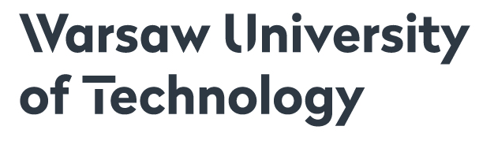

XIV INTERNATIONAL WORKSHOP
NONLINEAR OPTICS APPLICATIONS
NOA 2018
Wrocław, Poland, May 23-26, 2018

APPLICATION FORM

First name & surname:
Institution:
Address:
Telephone:
Fax:
E-mail:

I would like to present a paper:
by:

Date of arrival Date of departure

I would like to book a hotel for the nights: 23/24 24/25 25/26

I would like to make an additional reservation for an accompanying person ( ) YES / NO

I would like to share my room with another participant of the Workshop NOA 2018

date signature

Application form should be send to noa@if.pw.edu.pl till March 15th, 2018

